Endangered Missing

Deborah J. Centeno

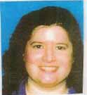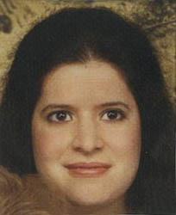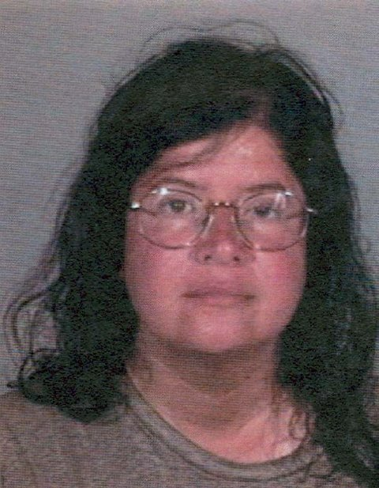

DOB: April 5, 1957 Sex: Female
Missing Since: Originally Missing Nov. 2004 Race: Hispanic
Age: 48 Hair: Black
Eye Color: Brown Height: 5’1”
Missing From: Santa Barbara, CA Missing Country: United States

Miss Centeno is fair skinned and may be sunburned. She was last seen at Cottage Hospital in the very wee hours of the morning on Sept. 16, 2005. Deborah had been seen walking on a dark stretch of highway in the very late night hours on Sept. 15, 2005. She was told by the Highway Patrolman that she could not walk the highways in California, and was taken into Cottage Hospital in Santa Barbara by them. Deborah refused medical aid at the ER facility, and was released. The Highway Patrol officer gave Deborah her sisters phone number, and Deborah said she was going to attempt to make contact with her. However, after leaving the facility, Deborah has not made contact with her sister. Deborah is very truthful. Her sister feels that if she told the patrolman she was going to attempt contact with her, that she would have attempted to do so. So, after approx. 73 days her sister notified the police in Santa Barbara that no contact had been made by Deborah at all. In conversations with people that live in the local area her sister has discovered that Deborah was in a desolate, dark stretch of road that was off the Highway when she was found by the police. Upon leaving Santa Barbara, if she did, the roads ahead were going to be very difficult and treacherous to walk trying to get to the next towns. The next services were going to be approx. 50 - 100 plus miles away from Santa Barbara. Upon being seen in California we now realize that Deborah more than likely hitched the 600 miles to get that far. That was very uncharacteristic of Deborah to take such a dangerous risk. But, since her arrival in California Deborah is now appearing to move much more slowly. When she has been seen she is walking, and now has absolutely no belongings, and no ID.

ANYONE HAVING INFORMATION SHOULD CONTACT

SANTA BARBARA POLICE DEPT.
Sgt. Ross Molina
1-805-897-2335
Case Number--05-290-51
or
FINDMONICAFOUNDATION INC.
1-877-499-3100
tips@findmonica.org

This flyer is provided courtesy of FindMonica Foundation Inc. organization.

